App name: Nudge
Inter Business Communication application

Team Crab
Sam Van
Nathan Wheeler
Aidan Carty
Logan Madden
Nicholas McHugh

Problem
Students in the computer science fields often struggle post transition to the professional world due to anxiety and struggling to feel comfortable. The junior developer may struggle to ask for help when an error is encountered due to their discomfort. Internships attempt to lessen the gap through real world experience, however interns are often made to complete smaller tasks deemed less important, which fails to make them more confident. (This lack of confidence can stem from a fear of seeming less capable, which can make a person hesitate to seek help based on a self perceived criteria of what was supposed to be learned at this point.) How might we facilitate junior developers to feel confident enough to ask questions within professional environments?

Prior Solutions

Solution 1: Microsoft Teams

Microsoft Teams is an internal communication tool for organizations to chat, meet, assign work, and collaborate. It focuses on integrating Microsoft products to allow teams to collaborate on work, share calendars and meetings, and host files all on one hub. This makes Teams a perfect environment for structured collaboration and project management.
However, the structure of Teams can be a downside and feel unapproachable, especially for junior developers. Group channels and direct messages are framed around productivity and accountability, especially when a user’s name is attached to everything they do on the platform. This can create pressure for users to look competent rather than be uncertain. For junior developers, this can hinder help seeking and hurt company culture by enforcing a work-first environment rather than providing a safe learning space.

Our app would be different by shifting away from a focus on strictly task-based communication and implementing more confidence-building support. A ticket system, with the option for users to be anonymous, would help alleviate the pressure that junior developers might feel from directly asking superiors. This ticket system would (ping the asking user with status updates on their question, to) also ensure that no developer feels ignored or forgotten as can often happen on a platform like Teams when other people are too busy or don’t want to respond to the request for help. Our app would focus on providing users with psychological safety and effective learning, unlike Teams which focuses on providing efficiency and accountability.

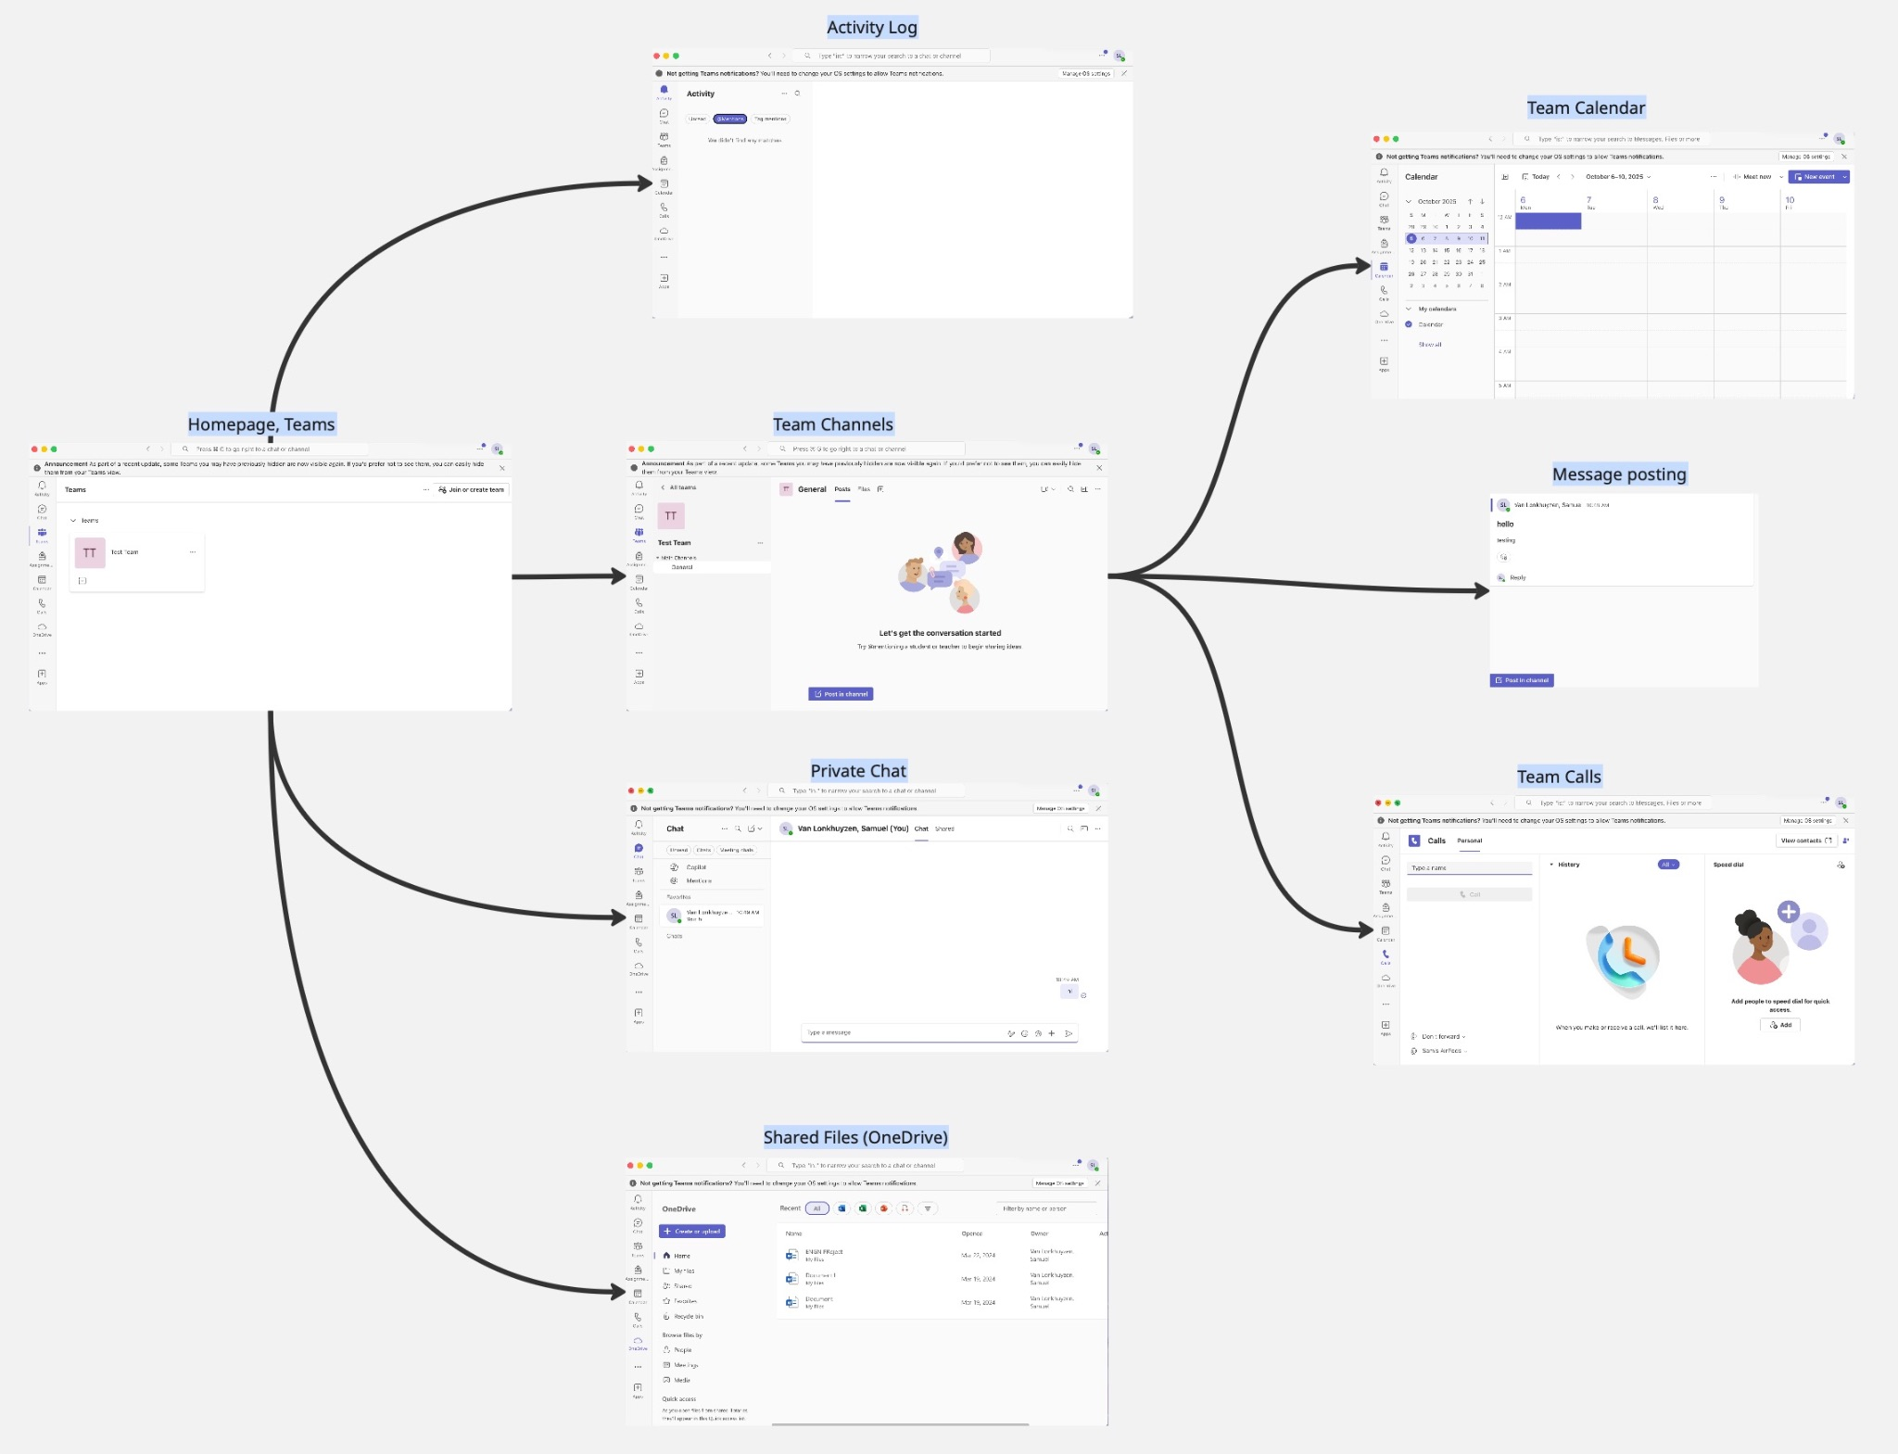
Microsoft Teams Miro Board

Solution 2:
Slack is a platform that provides the tools necessary to work cooperatively with those within and outside your company. It uses ai to create a smoother work flow and to assist its users in any projects they may be working on. The website comes with a variety of tools that assists in both communicating and working with a team, connecting all team members together to ensure both quality and efficiency in the workplace. The use of ai only amplifies the already existing tools and makes it easier for team members to keep up with and support their colleagues

One problem that the website doesn’t address is the challenge of asking for help initially. Slack has plenty of tools to support teams and corporations in working on projects, however it doesn’t change the fact that for someone new, asking for help is always difficult. We plan to include an anonymous mode to provide an extra layer of support, allowing users to ask questions that they may feel uncomfortable asking, whether it be because they feel the answer should be obvious or that it should be something they already know. We also plan to provide a wider corporate framework, not only allowing cooperators to create teams to work together, but to allow corporations to create groups that unify everyone within their company and allowing a wider web of connections for answers and questions.

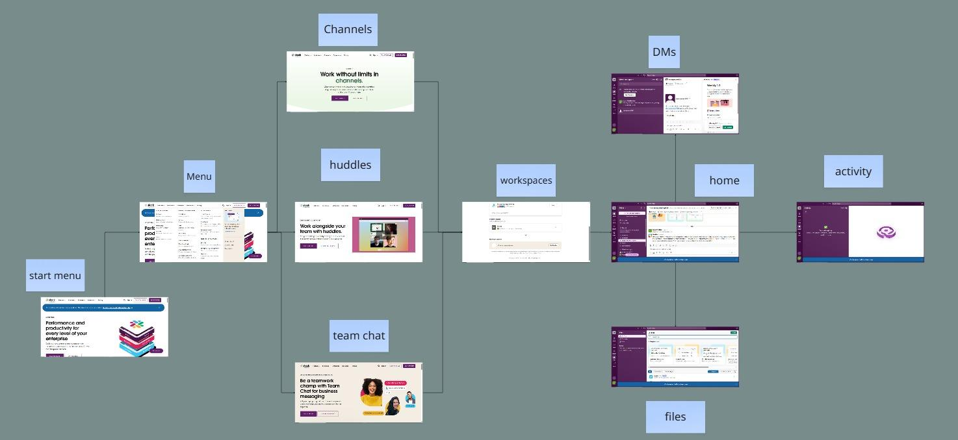

Slack Task Diagram

Solution 3: Stack Overflow
Stack Overflow is a public Q+A platform for programming and development problems. Stack allows you to quickly access hard to reach programming knowledge through its post organization,like tags and voting systems. It also allows teams to work together in Stack Overflow for Teams where you can have the Q+A in a smaller, more controlled space. This helps people reach help in a quicker, more comfortable manner while also allowing people to do the same for their specific teams.

Our app attacks the same problem in creating a q+a, type board to reach information quickly especially if maybe struggling to feel comfortable asking people above you in any professional format, but we will also have a help ticket type function to our questions, along with anonymous user possibility to further help those feel comfortable. Our app also plans to have subsections of our help areas that belong to companies that they can set up so that people that share a position across the country can answer and resolve a common question at said company position. We will implement personal messaging so that you can further expand on certain topics along with maybe connecting with those in your own company to build confidence in your own workplace.

Stack Overflow Task Diagram:

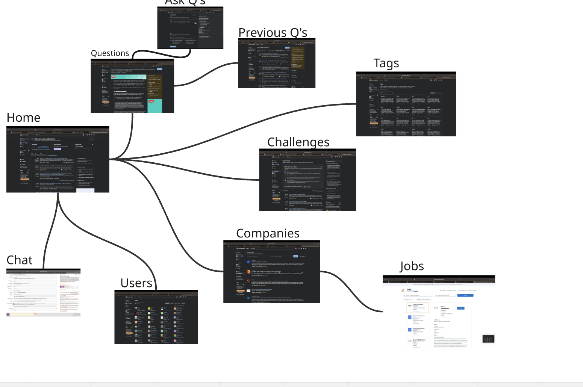

Nudge
At its core, Nudge is a messaging platform where companies/groups can manage questions they may have about their work. Messages can take the form of traditional direct messages or anonymous posts on a central question board where their question can be collaborated on by the whole group so an answer is achieved in a way that ensures the person with the question can continuously feel comfortable throughout the process.
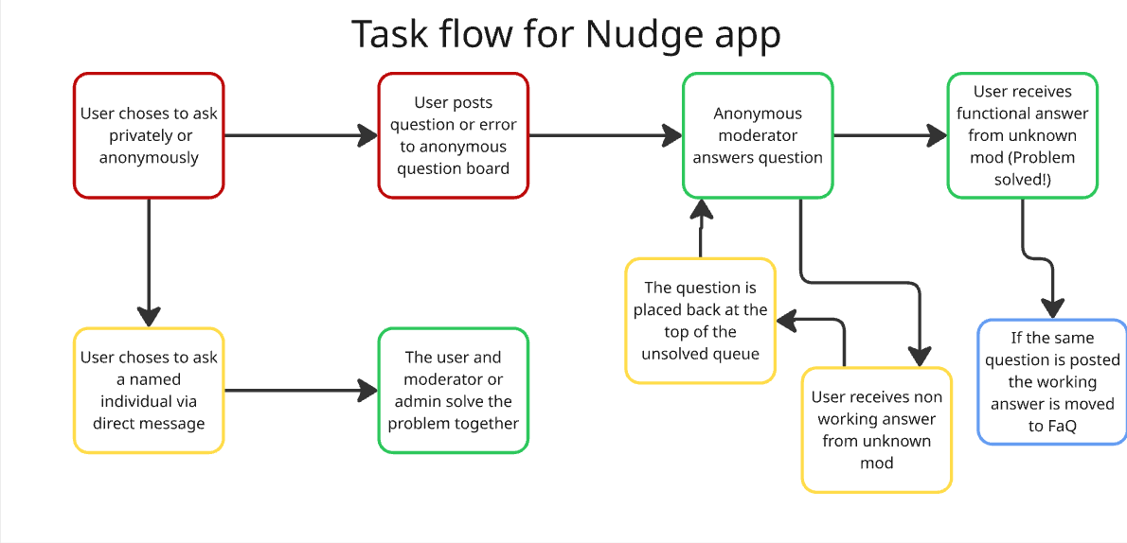
Team C Miro Board Task flow
Nudge will be an app that allows groups of individuals to create a space where they can ask and answer questions anonymously. If an individual has a question they can navigate to the appropriate created space and post a question, the question can then be viewed by all others in that space, without any ability to see who posted the question. If another individual has the answer, they will be able to post their answer. The answer will be able to be seen by all individuals in the space and can be given feedback by all individuals with a priority given to the individual who posted the question. If a question is asked multiple times, a frequently asked questions(faq) list will be created and the question and all answers added to the list. Additionally there is the option to directly message others if the question is too niche to need the observation of the whole space. Due to the nature of anonymous questions, an individual can be assigned the role of moderator, so they can ensure no questions are of an inappropriate nature and the individual who created the question can be discovered. Individuals who can not moderate the content can instead report questions to bring them to the attention of moderators.
When an individual feels their questions are not worth to be asked, for whatever reason, they will struggle to solve the issue on their own even if asking their question would typically be faster. To encourage the asking of questions by these individuals, Nudge allows any shame (helps remove the fear of asking “dumb” questions, by encuraging anything a user might be confused about to be asked through direct messaging or anonymous asking.)from asking the question to not exist through its use of anonymous questions. Additionally by allowing all questions to be seen, anyone else who had the same question can visit their space to see if the question had already been asked and answered; this is made especially easy if the questions exists in the faq list already. This potentially removes the issue of asking the question entirely. For the questions that are not hard to ask or that need specialty help, typical direct messaging is also available to be used. As an individual asks more questions, they will begin to accumulate the knowledge and skills needed to ask less questions or only more advanced questions thus allowing them to be more confident in their work and in their ability to rely on their coworkers for assistance.

